Creating a new spring project using spring initializr
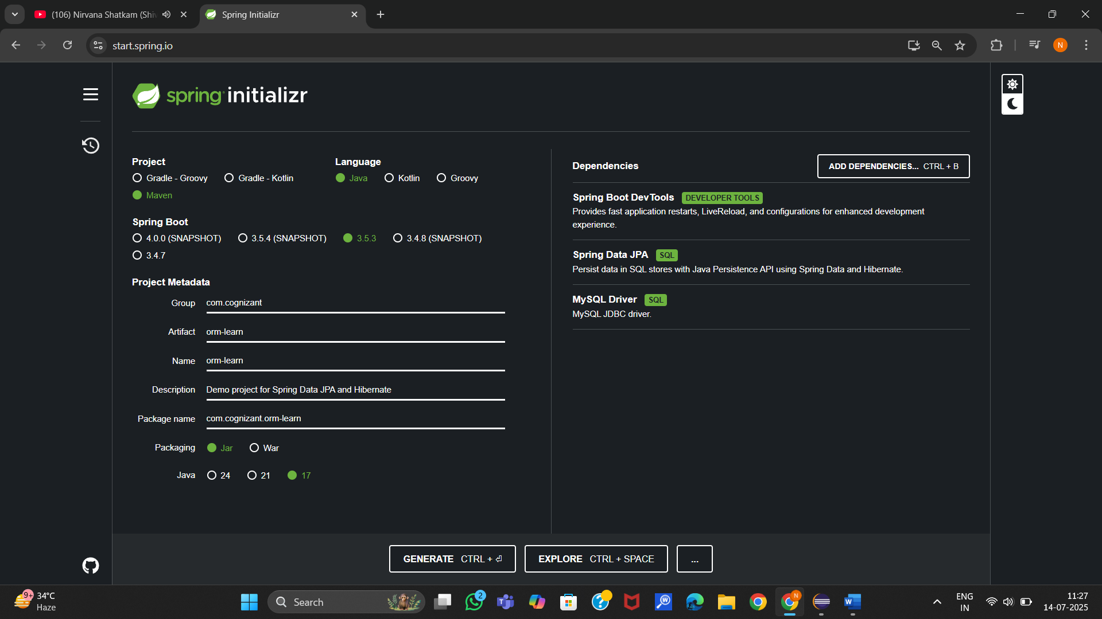
Opening the project in the eclipse.
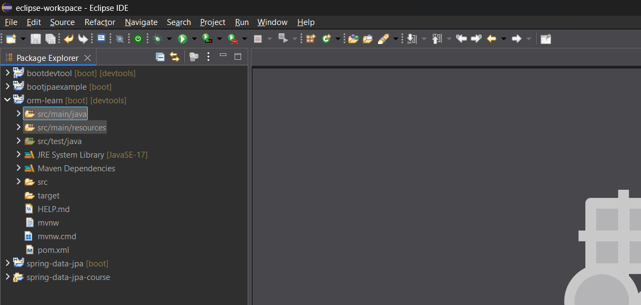
Created a new database with the name ormlearn in mysql workbench.
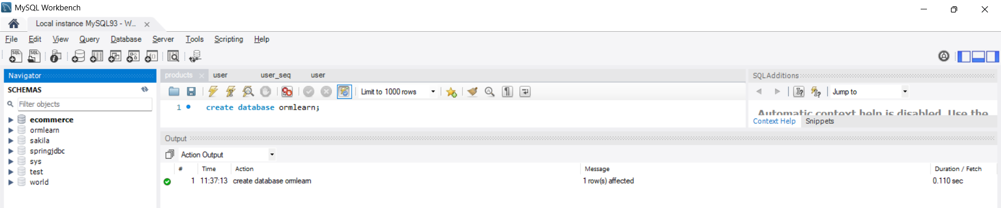

Configured the application.properties file
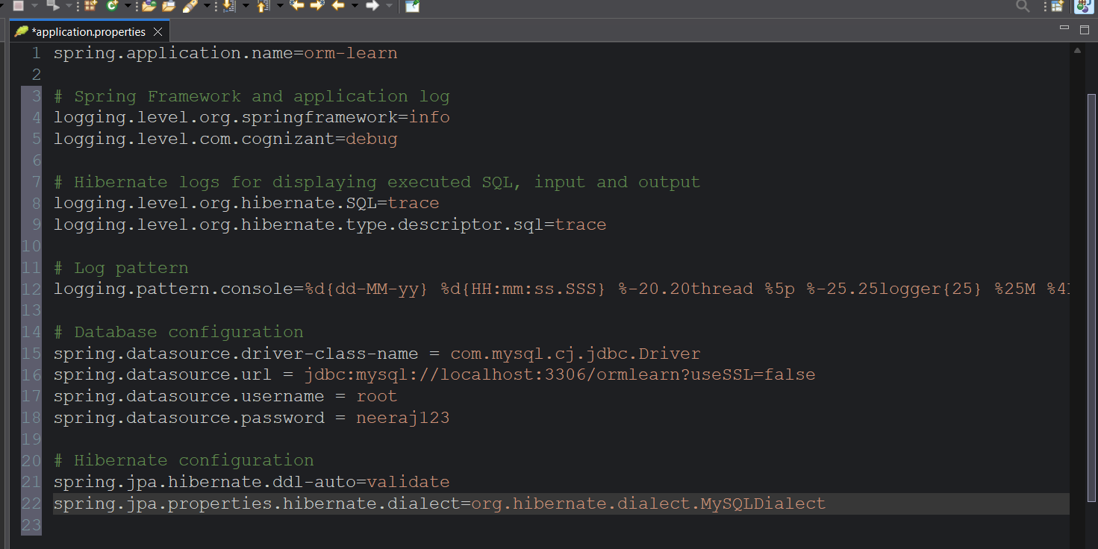
Build the project using ‘mvn clean package -Dhttp.proxyHost=proxy.cognizant.com -Dhttp.proxyPort=6050 -Dhttps.proxyHost=proxy.cognizant.com -Dhttps.proxyPort=6050 -Dhttp.proxyUser=123456’ command in command line

Include logs for verifying if main() method is called.
Dependencies tree and folder structure.
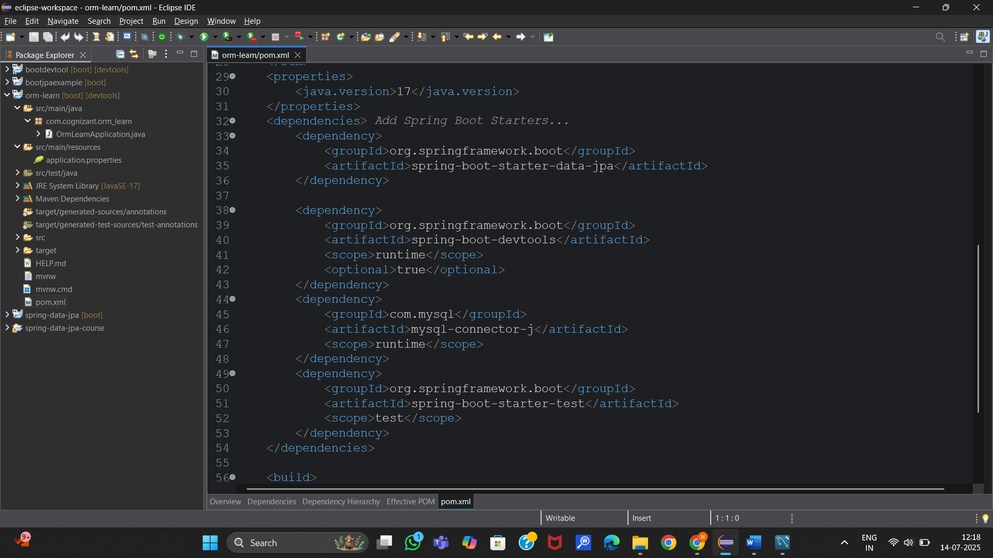

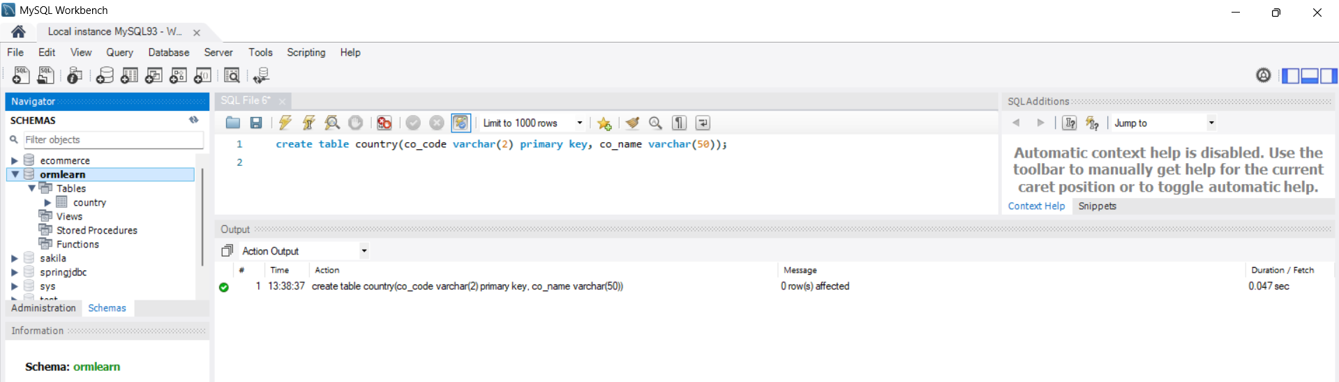
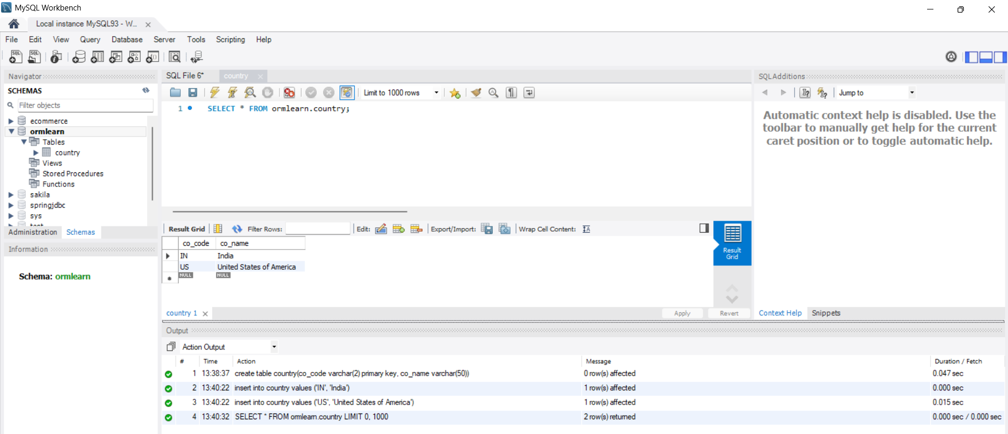
Create a model class Country in the com.cognizant.orm_learn.model package
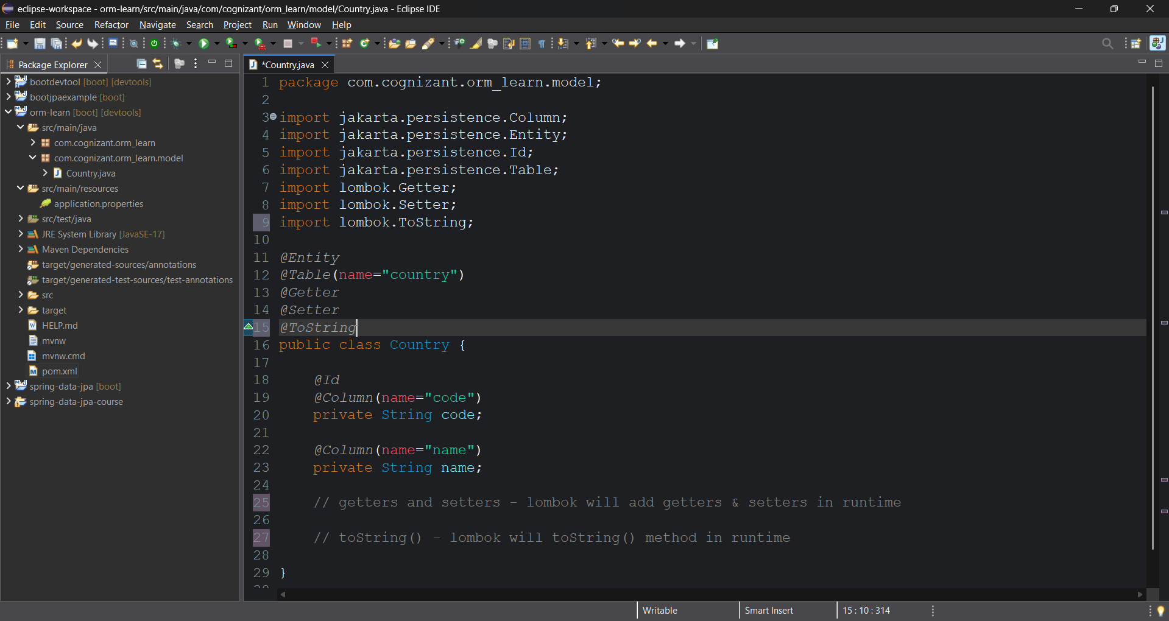
Add dependencies of Lombok in the dependencies to get getters and setters in runtime which reduces code.

Create new repository class for the country in the com.cognizant.orm-learn.repository
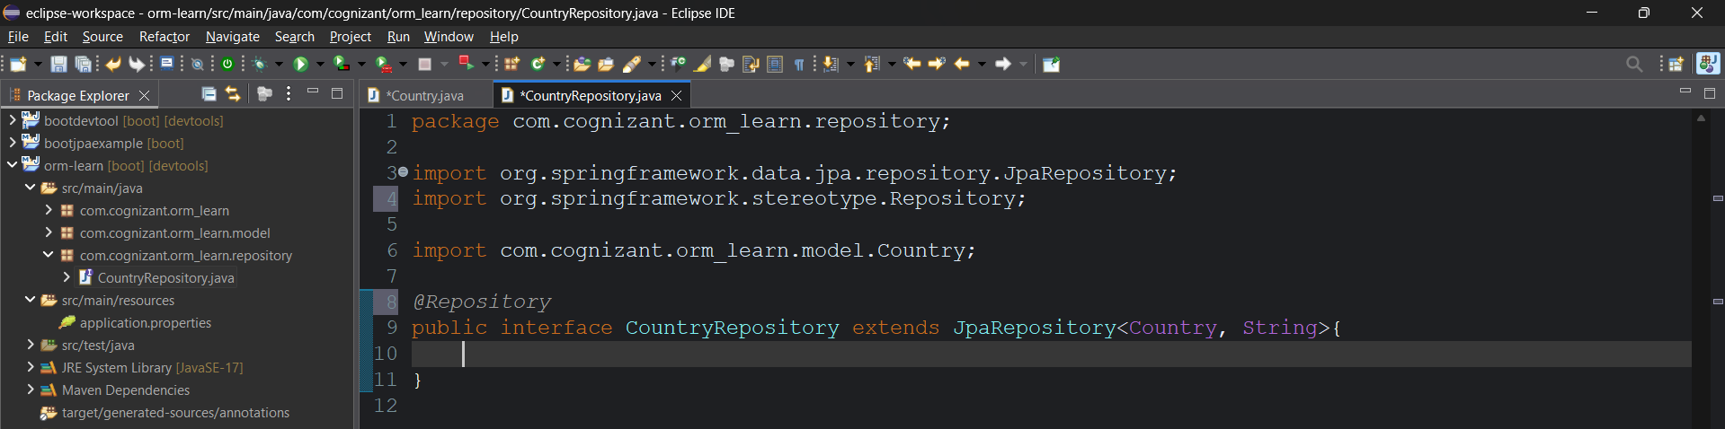
Create a CountryService.java class in the com.cognizant.orm-learn.service
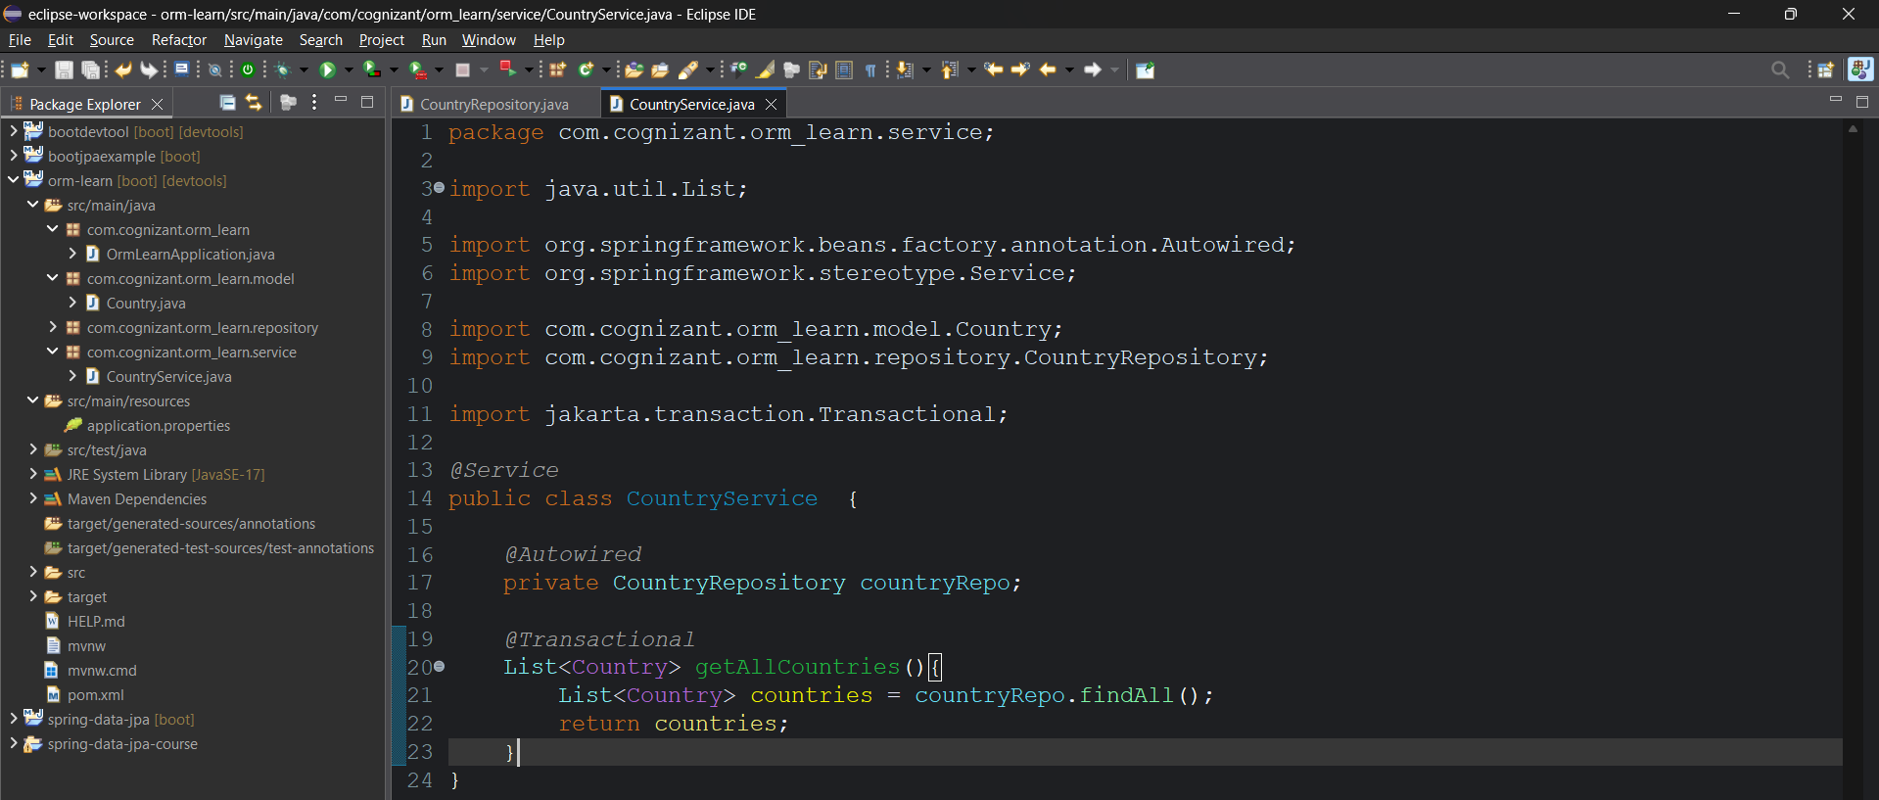
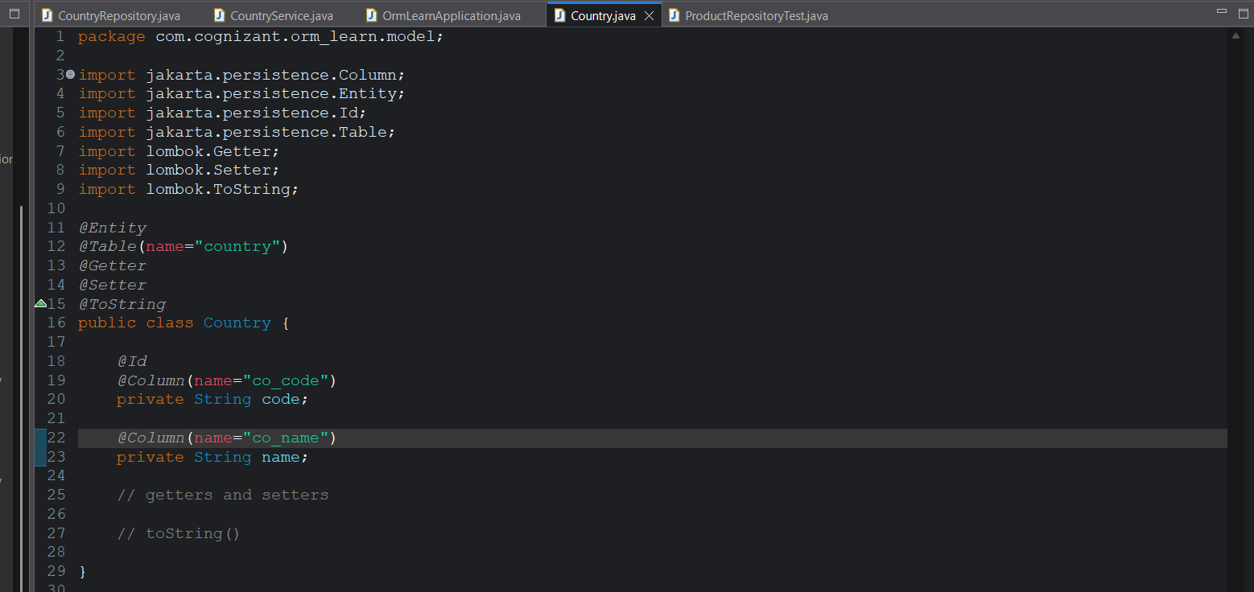
Change the column names to co_code & co_name since we have named them like that in the database;
Otherwise we will get error.
